Manitoba Renal Technology Site Content – section 3

Content Grouping and Labelling – section 3.1
Homepage
- Links to Main Areas (Home Patients, Facilities, Support Contact)
- Picture of equipment with mission statement
Home Patients
- Equipment
  - pictures of each equipment
  - information, FAQ link and equipment manual link
Facilities
- Equipment at each facility
  - information, FAQ link and equipment manual link
Support Contact
- Technical support form
- Contact information
Content Available on All Pages
- Privacy Policy
- Terms of Use
- Basic Contact information
- Manitoba Renal Technology Logo

Functional Requirements – section 3.2
Contact Support Form
The site user will be able to fill out a form to request more information on their equipment or the program.
Time to develop, test and implement this feature: .5 days.
Social Network Links
The site user will be able to add Manitoba Renal Technology to their Twitter and Facebook feeds

Manitoba Renal Technology Site Structure – section 4

Architectual Blueprint – section 4.1

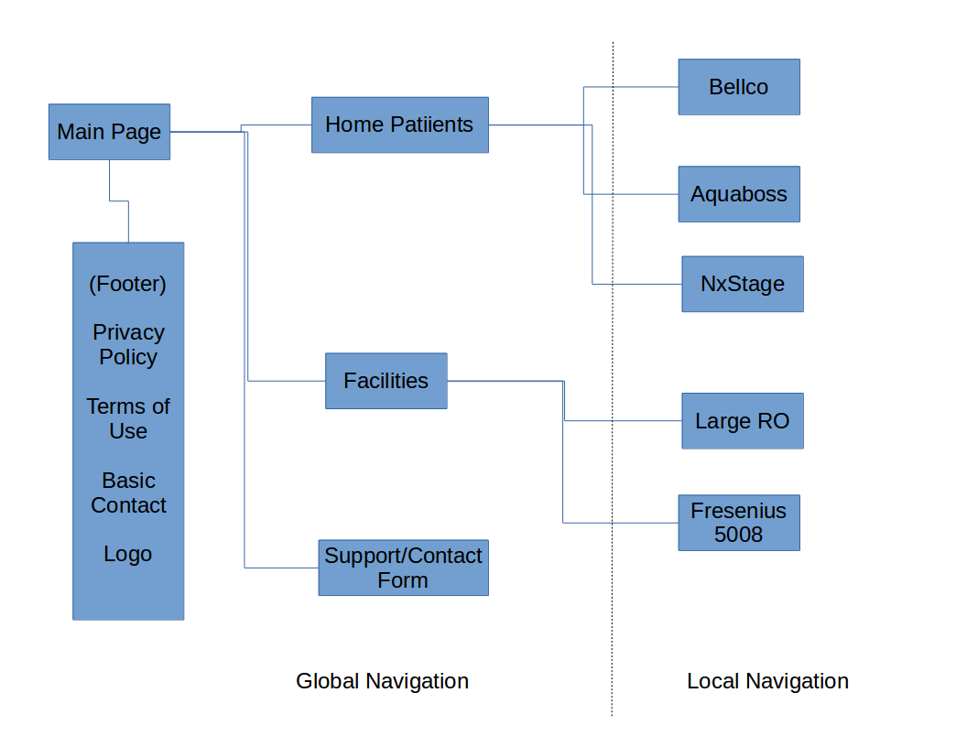
Global and Local Navigation Systems – section 4.2
Global navigation will consist of links to Home Patients, Facilities and the Support/Contact Form within the header. The header will be pinned to the top. Within the footer of the global navigation will be links as listed in the architectual blueprint. The footer will scroll from the bottom of the content.
Local navigation will consist of a pinned left side navigation bar that will change depending on the global navigation setting:
Home Patients – when this is selected the left menu will display equipment that home patient users may have installed at their location – Bellco, Aquaboss, NxStage. A standard equipment page consisting of a picture, an FAQ, and manual download link will be displayed upon clicking the items in the left menu.
Facilities – when this is selected the left menu will display equipment that facilities mya have installed – Large RO, Fresenius 5008. A standard equipment page consisting of a picture, an FAQ, and the manual download link will be displayed upon clicking the items in the left menu.
Support/Contact – when this is selected detailed contact information will be displayed in the content area along with an online form that can be filled out for comments or questions.

